BAY Shul - Bais Ahavas Yisroel
Succos Schedule 5776/2015

Sunday, September 27 - Erev Succos
Candle Lighting*...................... 6:20 P.M.
Mincha**.................................. 6:25 P.M.
Ma'ariv**.................................. 7:15 P.M.
Kiddush in Sukkah after……....7:30 P.M.

Monday, September 28 - 1st Day of Succos
Shacharis................................ 9:00 A.M.
Mincha**.................................. 6:20 P.M.
Candle Lighting*...............after 7:28 P.M.
Ma'ariv**.................................. 7:10 P.M.

Tuesday, September 29 - 2nd Day of Succos
Shacharis..................................9:00 A.M.
Mincha**....................................6:15 P.M.
Ma'ariv ………………………......7:40 P.M.

Wed. – Fri., Sept 30 – Oct 2 Chol HaMoed
Shacharis.................................... ..6:00 A.M.
Mincha/Maariv (Wed & Thurs)...….6:20 P.M.

Shabbos, October 3 – Chol HaMoed
Shacharis………………………..9:00 A.M.
Mincha**……………………… 6:00 P.M.
Ma’ariv….…………...……………7:30 P.M.

Sunday, October 4 - Hoshanah Rabbah
Candle Lighting*.................. 6:08 P.M.
Mincha**.............................. 6:10 P.M.
Ma'ariv**.............................. 6:40 P.M.

Monday, October 5 - Shmini Atzeres
Shacharis............................ 9:00 A.M.
Yizkor.....................approx.10:30 A.M.
Mincha at BAY Shul........... 6:05 P.M.
Ma'ariv-Hakafos at BAY Shul ....7:10 P.M.
Candle Lighting*..................after 7:16 P.M.


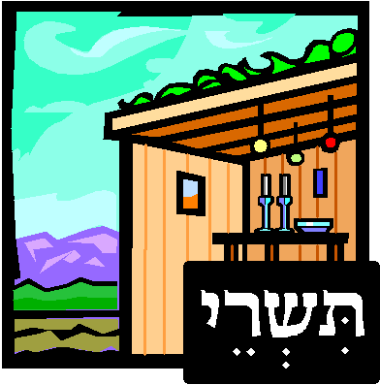
Tuesday, October 6- Simchas Torah
Shacharis........................................ 9:00 A.M.
Hakafos...............................approx. 10:15 A.M.
Mincha...............................after davening.
Community Seuda/Meal after mincha
see Order Form for details
Maariv…............................................7:25 P.M.

Shabbos Bereishis, October 10
Shacharis………………..……..9:00 A.M.
Mincha**……………….….……5:50 P.M
Ma’ariv…..………………………7:20 P.M.

* Refer to Siddur for proper blessings
** check for location

